**STS Installation Guide**

|  |  |  |  |
| --- | --- | --- | --- |
| **Revision** | **Date** | **Author** | **Comment** |
| 1.0 | 04/19/2019 | Lavi | Initial version |
|  |  |  |  |

### Installation files for STS

**Download pre-configed STS from our ftp server:**

/software/webportal/sts-bundle-3.9.6.zip

/software/webportal/.m2.zip

/software/webportal/jdk-8u91-windows-x64.exe

### Installation JDK

**Click “jdk-8u91-windows-x64.exe” to install JDK and setup JAVA_HOME like this in your system path:**



### Installation for STS

**Step1:** Find 2 files from first section:

sts-bundle-3.9.6.zip & .m2.zip

**Step2:** Exact sts-bundle-3.9.6.zip to any folder like this(here it’s root of disk d), you can see that STS.exe is in here:

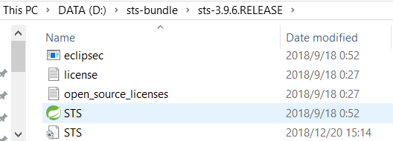

**Step3:** Exact .m2.zip to your current user’s home folder (replace “Netgear” to your user name below) like this:

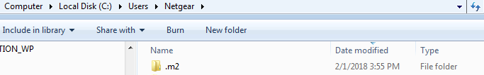

### Import web portal project into STS

**Step1:** Launch STS, right click inside the “Package Explore” to select “import…” menu

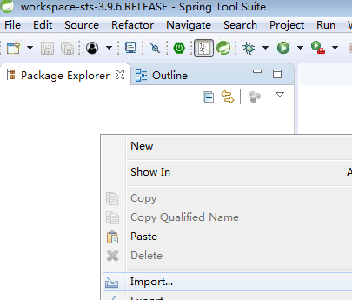

**Step2:**  Select “Existing Mav Projects” below and click Next:

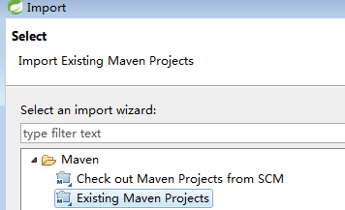

**Step3:**  Select root path of webportal over “Browse…” button and you will see a pom.xml, click Finish after you select it:

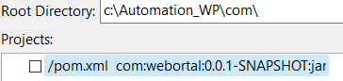

**Step4:**  Check folder layer should be like below:

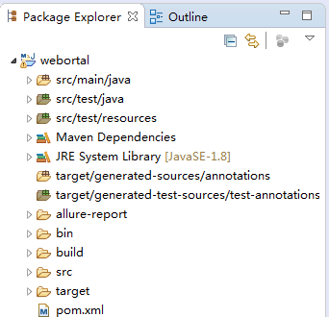

### Do configuration and run for web portal

**Step1:** Config_dut.xml for device configuration, config_webportal.xml for account:

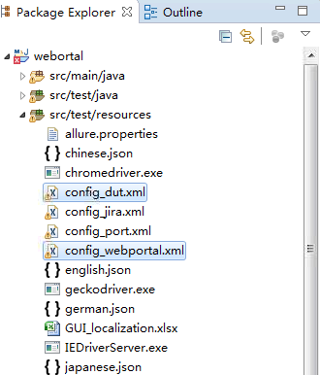

**Step2:** Pick “Run As->TestNG Test” menu on any TestCase.java file to run test:

